To establish learning ambience for ushering in computer engineering professionals in core and multidisciplinary area by developing Problemsolving skills through emerging technologies.

Session | 2025-26 (ODD) | Course Name | Operating System Lab
Semester | 5 | Course Code | 23IOT1504
Roll No | 37 | Name of Student | Dhanashri Raut

Practical Number | 6
Course Outcome | - Understand Computer System Configuration and Simulate system resources efficiently using Linux Commands (CO1)  - Analyse operating system functionalities utilizing system calls, thread programming and process scheduling algorithms (CO2)  - Apply Synchronization primitives to implement a Deadlock-free solution(CO3)  - Simulate Disk scheduling, Memory allocation, File allocation, page replacement algorithms (CO4)
Aim | Simulate the Page Replacement Algorithms (Any Two)  - First in First Out (FIFO)  - Least Recently Used (LRU)  - Optimal
Problem Definition | - First in First Out (FIFO)  - Least Recently Used (LRU)
Theory | In a virtual memory system, pages from secondary memory (disk) are loaded into main memory (RAM) when needed. Since the number of physical frames is limited, when a new page is required and memory is full, one of the existing pages must be replaced. The choice of which page to remove is determined by the page replacement algorithm. The objective is to minimize page faults (when the required page is not in memory).  1. First In First Out (FIFO)  FIFO is the simplest page replacement algorithm. Pages are maintained in a queue — the oldest page (the one that entered first) is replaced first when a new page needs to be loaded.  • Advantages: Simple and easy to implement using a queue.
To establish learning ambience for ushering in computer engineering professionals in core and multidisciplinary area by developing Problemsolving skills through emerging technologies.

 | • Disadvantages: May lead to Belady’s anomaly — more frames can sometimes result in more page faults because it doesn’t consider usage patterns.
2. Least Recently Used (LRU)
LRU replaces the page that has not been used for the longest time. It assumes that pages used recently will likely be used again soon.
- Implementation: Can be implemented using a stack or by tracking the last used time for each page.
- Advantages: Good approximation of optimal performance.
- Disadvantages: Requires additional hardware or software overhead to maintain usage order.
3. Optimal Page Replacement
Optimal algorithm replaces the page that will not be used for the longest period in the future.
- Advantages: Produces the minimum possible number of page faults for a given reference string.
- Disadvantages: Not implementable in real systems (future knowledge needed), but used for theoretical comparison.
Give Procedure and Execution  (100 Words) | Steps for implementation:  - Read the number of frames and the length of the reference string.  - Input the reference string (page numbers).  - For FIFO, maintain a queue to store pages; when a page fault occurs and memory is full, replace the oldest page.  - For LRU, track the recent usage of each page and replace the one that has not been used for the longest time.  - Display the frame contents after each reference and count page faults.  - Compute and display the total number of page faults for each algorithm.
To establish learning ambience for ushering in computer engineering professionals in core and multidisciplinary area by developing Problemsolving skills through emerging technologies.

Code:
1.Code for FIFO :
#include <stdio.h>

int main() {
int frames[10], pages[30];
int n, f, i, j, k, pageFaults = 0, next = 0, flag;

printf("Enter number of pages: "); scanf("%d", &n);
printf("Enter reference string: ");
for (i = 0; i < n; i++) scanf("%d", &pages[i]); printf("Enter number of frames: "); scanf("%d", &f);

for (i = 0; i < f; i++)
frames[i] = -1;

printf("\nPage\tFrames\n");

for (i = 0; i < n; i++) {
flag = 0;

// Check if page already in frame
for (j = 0; j < f; j++) { if (frames[j] == pages[i]) {
flag = 1; break;
}
}

// If page not found -> replace using FIFO if (flag == 0) {
frames[next] = pages[i]; next = (next + 1) % f; pageFaults++;
To establish learning ambience for ushering in computer engineering professionals in core and multidisciplinary area by developing Problemsolving skills through emerging technologies.

}

// Display current frame status printf("%d\t", pages[i]); for (k = 0; k < f; k++) { if (frames[k] == -1) printf("- ");
else
printf("%d ", frames[k]);
}
printf("\n");
}

printf("\nTotal Page Faults = %d\n", pageFaults); return 0;
}
2..Code for LRU:
#include <stdio.h>

int main() {
int pages[30], frames[10], counter[10];
int n, f, i, j, k, pageFaults = 0, time = 0, flag, least;

printf("Enter number of pages: "); scanf("%d", &n);
printf("Enter reference string: ");
for (i = 0; i < n; i++) scanf("%d", &pages[i]); printf("Enter number of frames: "); scanf("%d", &f);

for (i = 0; i < f; i++) { frames[i] = -1; counter[i] = 0;
}

printf("\nPage\tFrames\n");
To establish learning ambience for ushering in computer engineering professionals in core and multidisciplinary area by developing Problemsolving skills through emerging technologies.

for (i = 0; i < n; i++) {
flag = 0;

// Check if page already in frames
for (j = 0; j < f; j++) { if (frames[j] == pages[i]) {
time++;
counter[j] = time; // update usage time flag = 1; break;
}
}

// If page not found -> replace LRU page if (flag == 0) { int pos = -1;
// Find empty frame for (j = 0; j < f; j++) { if (frames[j] == -1) {
pos = j; break;
}
}

if (pos == -1) {
// Find least recently used page least = 0;
for (j = 1; j < f; j++) {
if (counter[j] < counter[least]) least = j;
}
pos = least;
}

time++;
frames[pos] = pages[i];
To establish learning ambience for ushering in computer engineering professionals in core and multidisciplinary area by developing Problemsolving skills through emerging technologies.

counter[pos] = time; pageFaults++;
}

// Display current frame status printf("%d\t", pages[i]); for (k = 0; k < f; k++) { if (frames[k] == -1) printf("- ");
else
printf("%d ", frames[k]);
}
printf("\n");
}

printf("\nTotal Page Faults = %d\n", pageFaults); return 0;
}

Output:
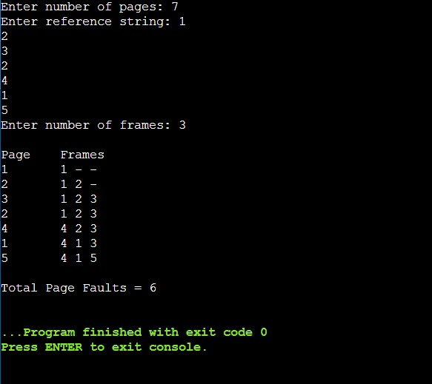1.Output for FIFO :
To establish learning ambience for ushering in computer engineering professionals in core and multidisciplinary area by developing Problemsolving skills through emerging technologies.

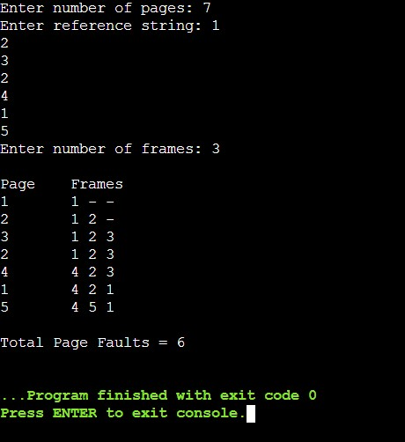
2.Output for LRU:

Output Analysis | From the above analysis, both FIFO and LRU gave the same number of page faults for the chosen reference string.  However, LRU generally performs better in most cases because it considers the recent usage history of pages, while FIFO simply removes the oldest one without regard to usage frequency.  Hence, LRU provides more efficient page replacement in practical systems.
Link of student Github profile where lab assignment has been uploaded | https://github.com/24030192-lab/-OS-Practicals
Conclusion | Hence simulated page replacement algorithm.

To be a well-known centre for pursuing computer education through innovative pedagogy, value-based education and industry collaboration. Mission of the Department
To establish learning ambience for ushering in computer engineering professionals in core and multidisciplinary area by developing Problemsolving skills through emerging technologies.

Plag Report  (Similarity index <  12%) | 
Date | 22/10/25

